SNS (Simple Notification Service)

1.Console Home

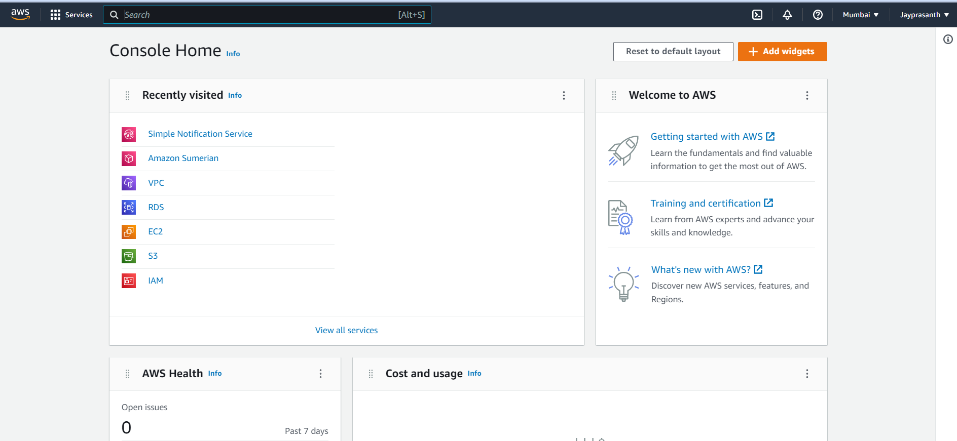

2.search SNS

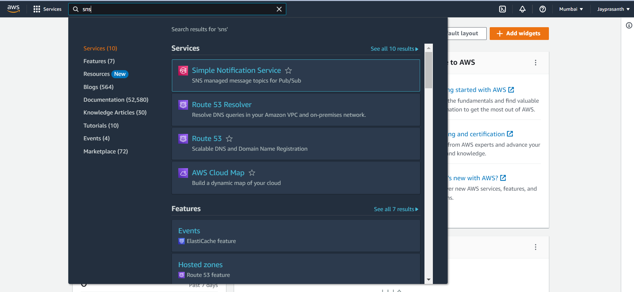

3.We want to create a topic

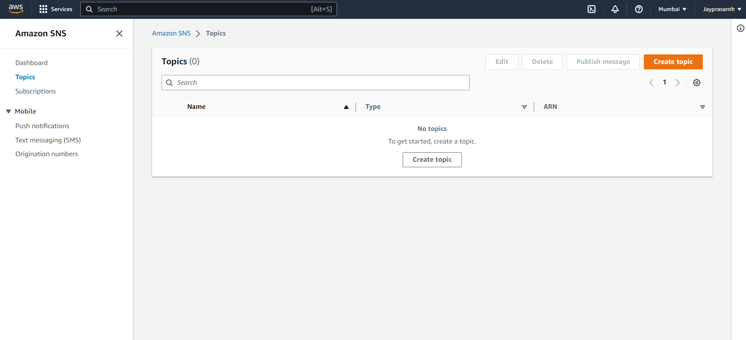

4.choose the type of topic

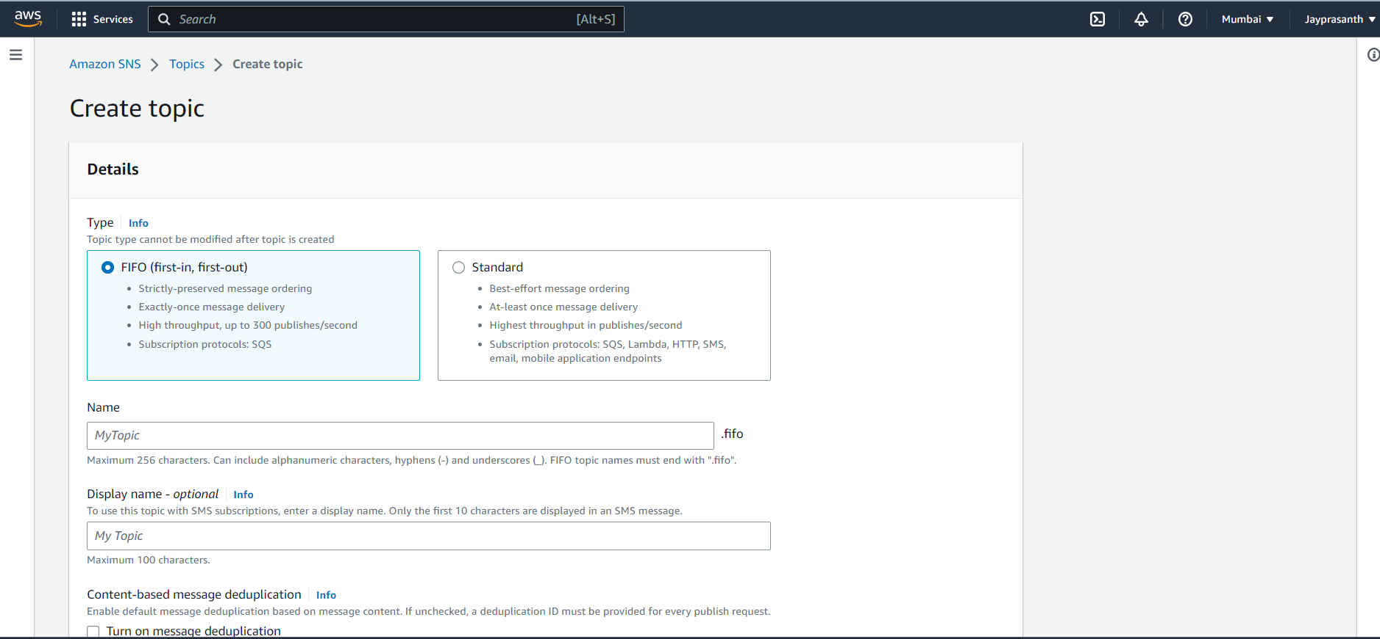

5.name and display name

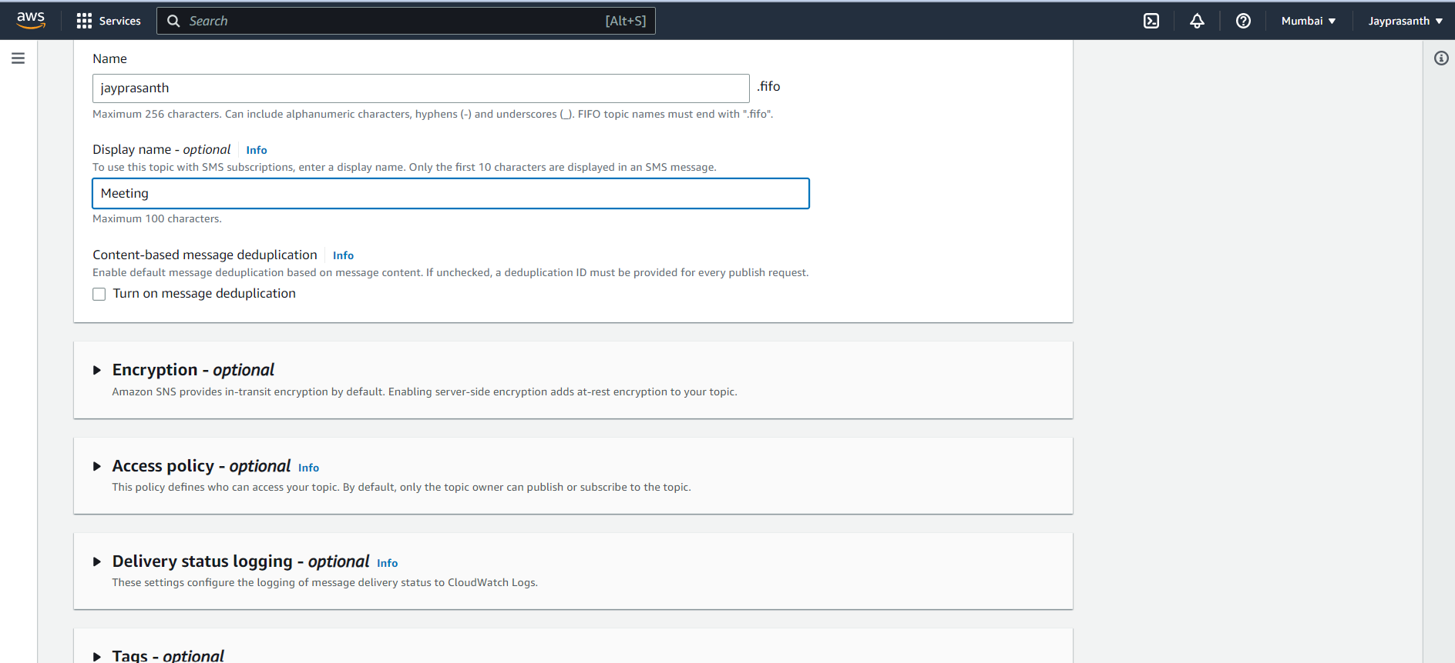

6.and click create topic

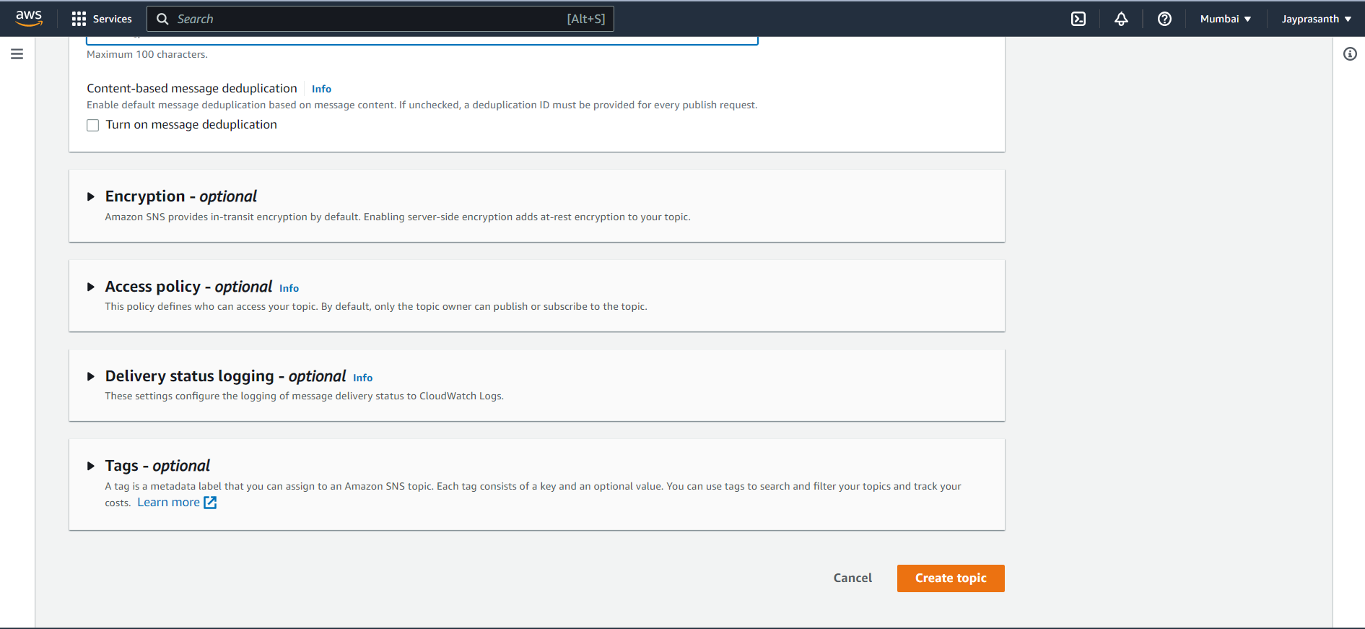

7. It successfully created

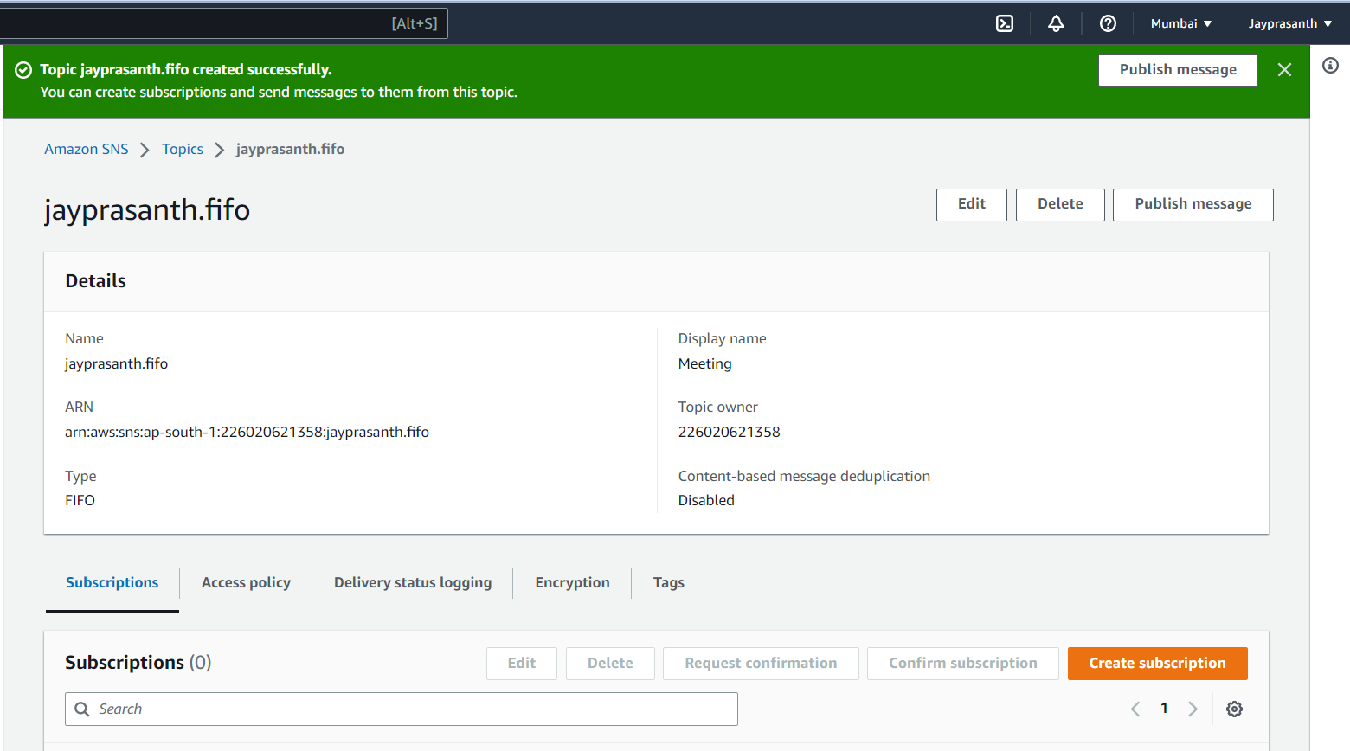

8. click topic and create a subscription to publish a message

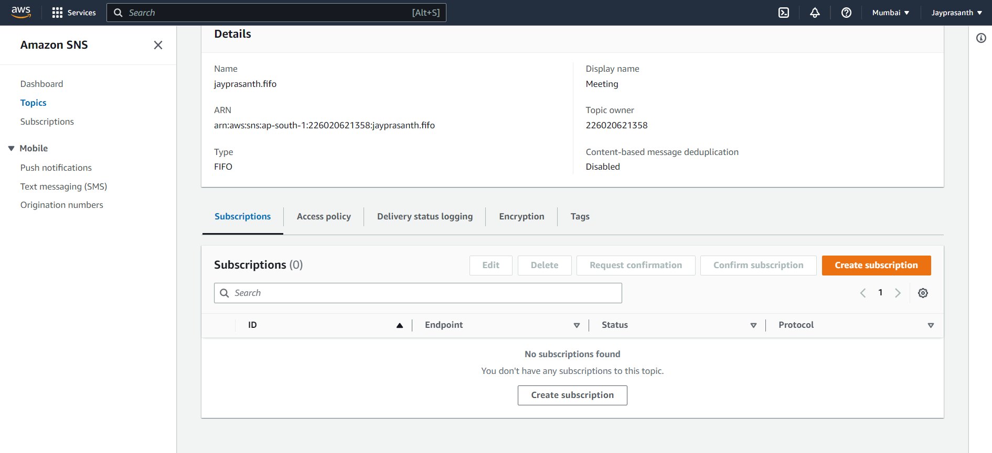

9.In the choose of topic type, protocol vary choose FIFO, it shows only amazon sqs and choose standard, it shows the email, SMS, and many

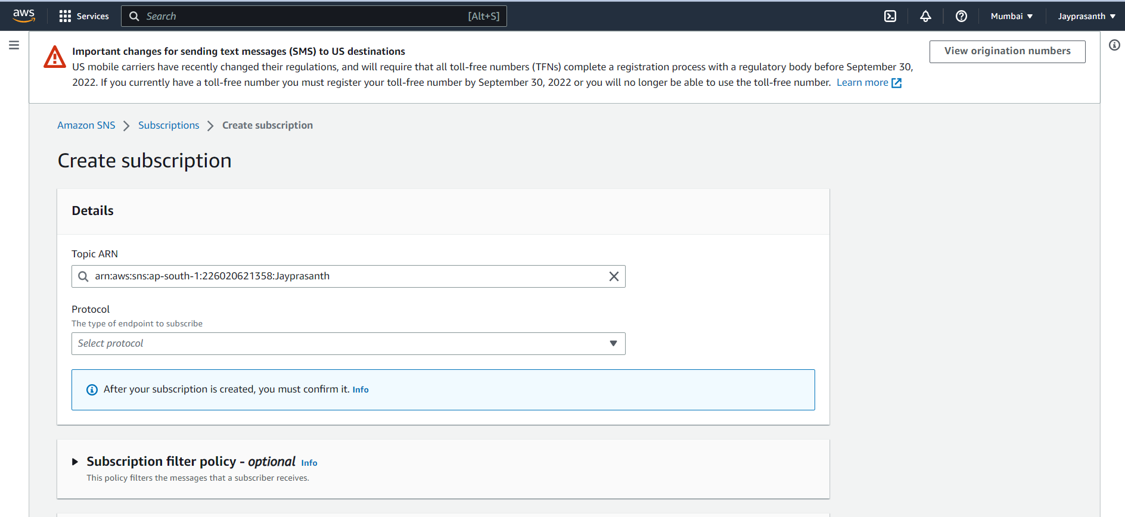

10.choose Email and type your email in the given box

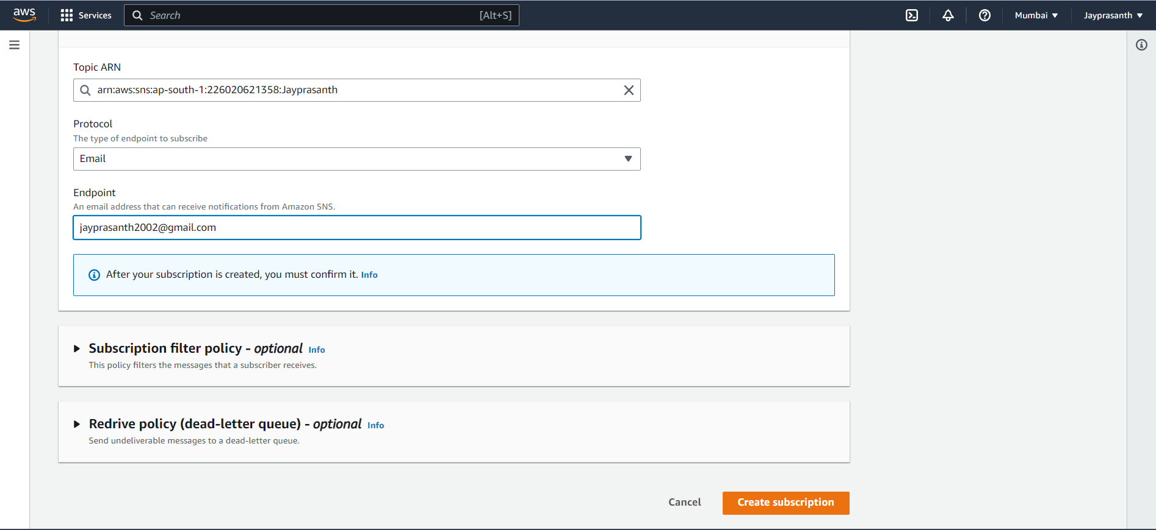

11.Successfully created

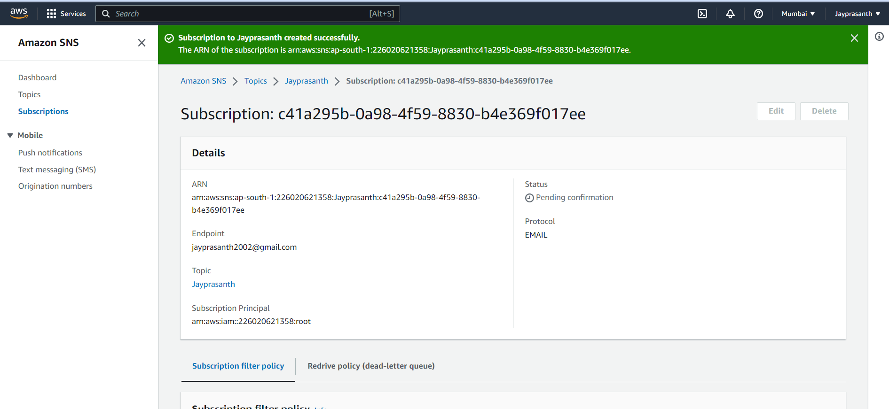

12. In the status, it shows only pending

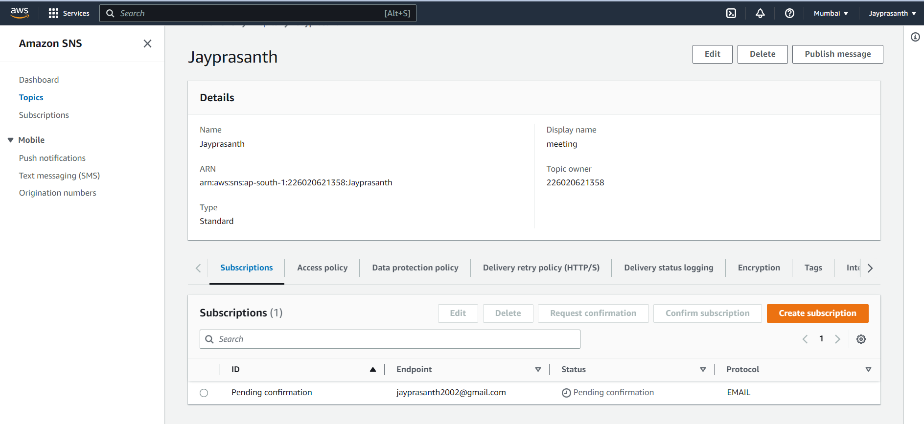

13. In email you want to confirm the subscription after only you can get a message

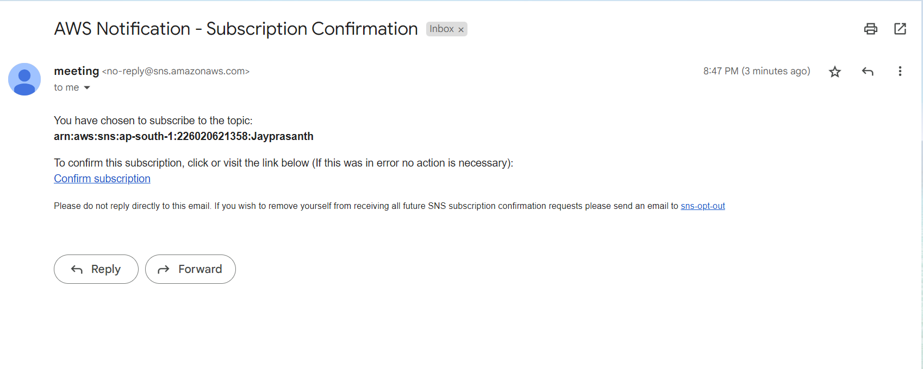

14.subcription confirmed

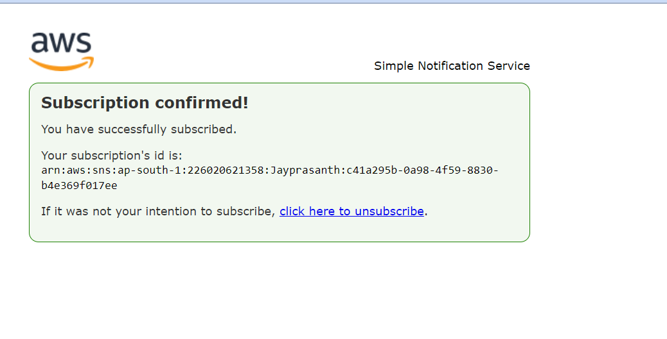

15.after that, click publish and type subject

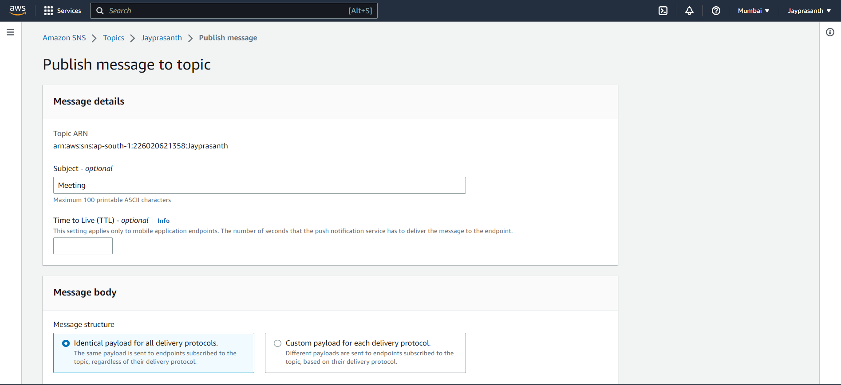

16. And type what you want in the body and click publish

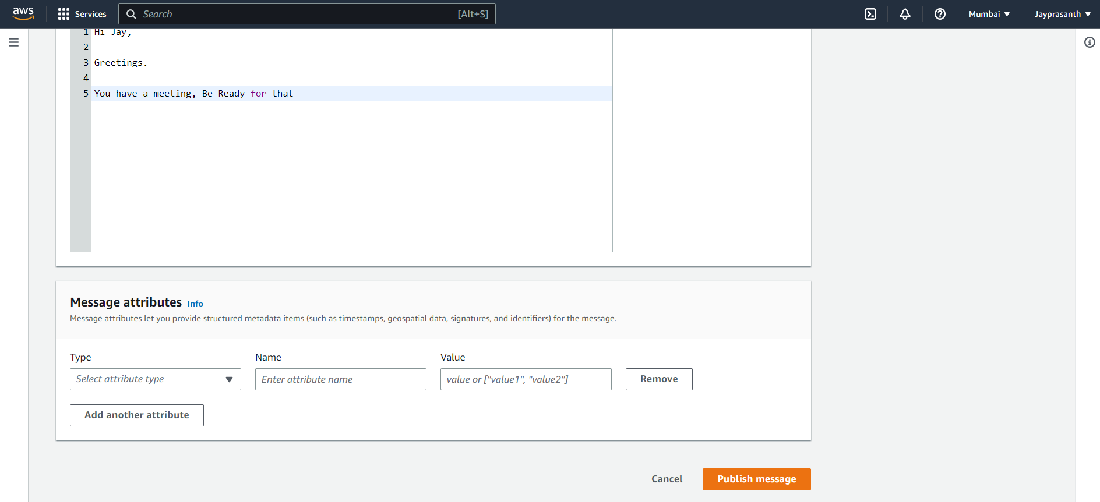

17.it shows the successfully published

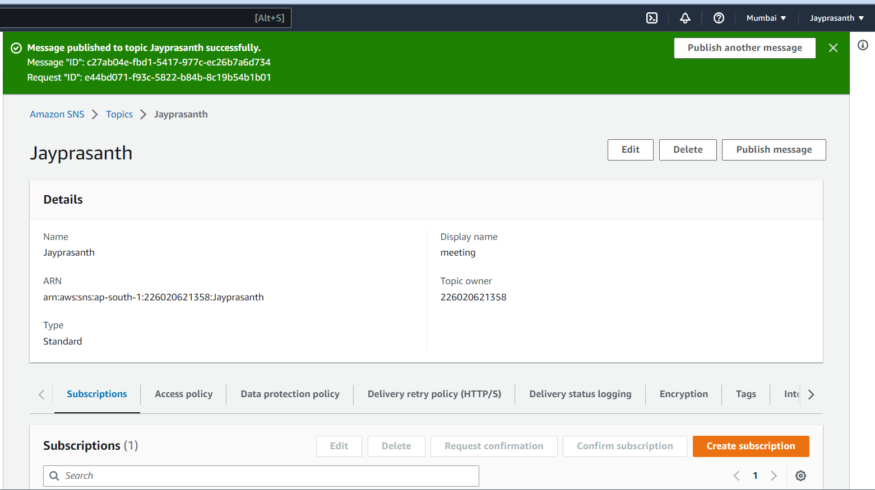

18. Get a mail from SNS.amazon.com

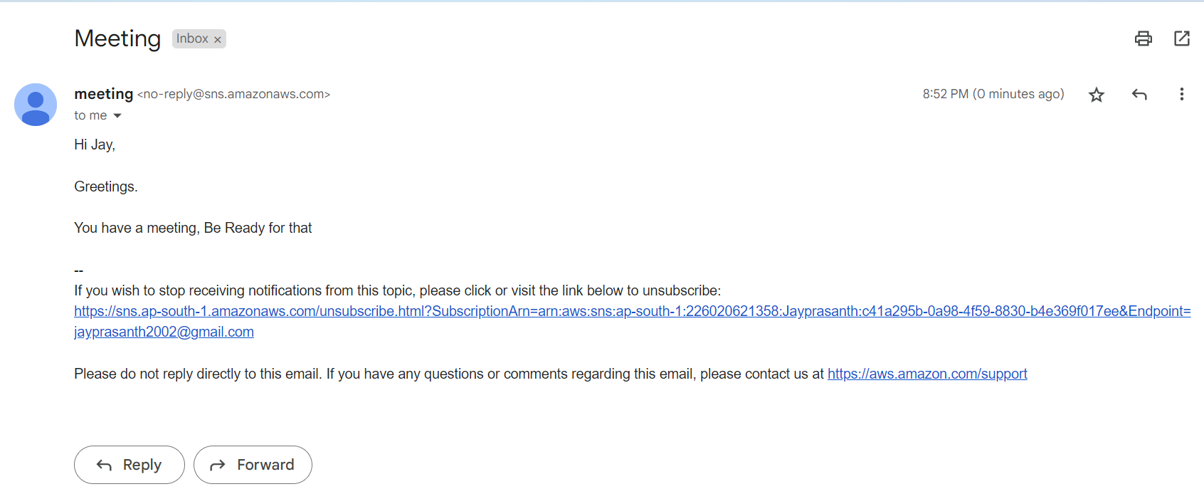

19.after all remove the subscription

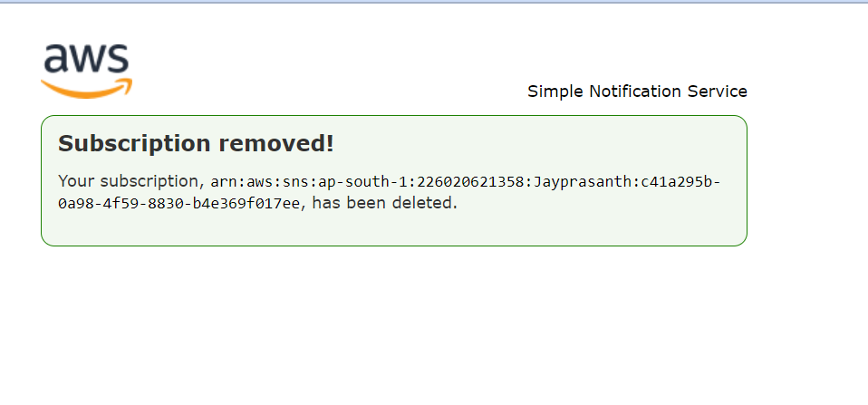

20. Click the checkbox of subscription and select the delete button

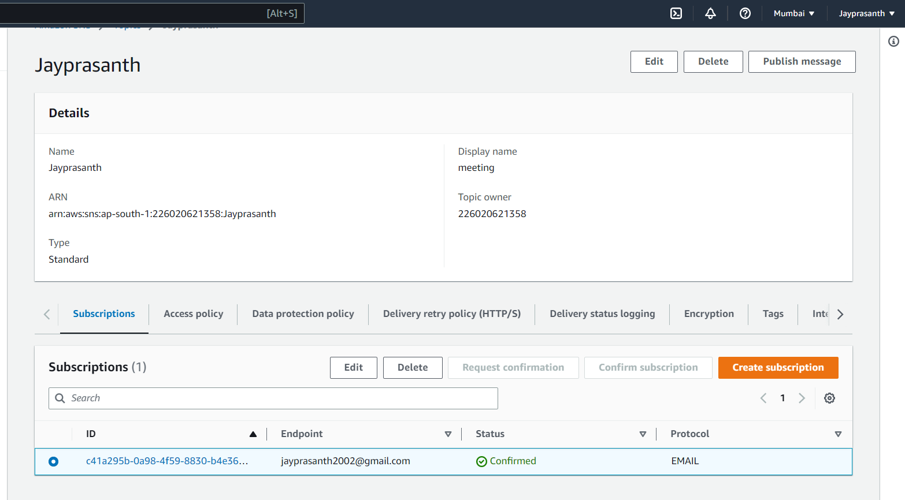

21.after deleting subscription only you can delete the topic

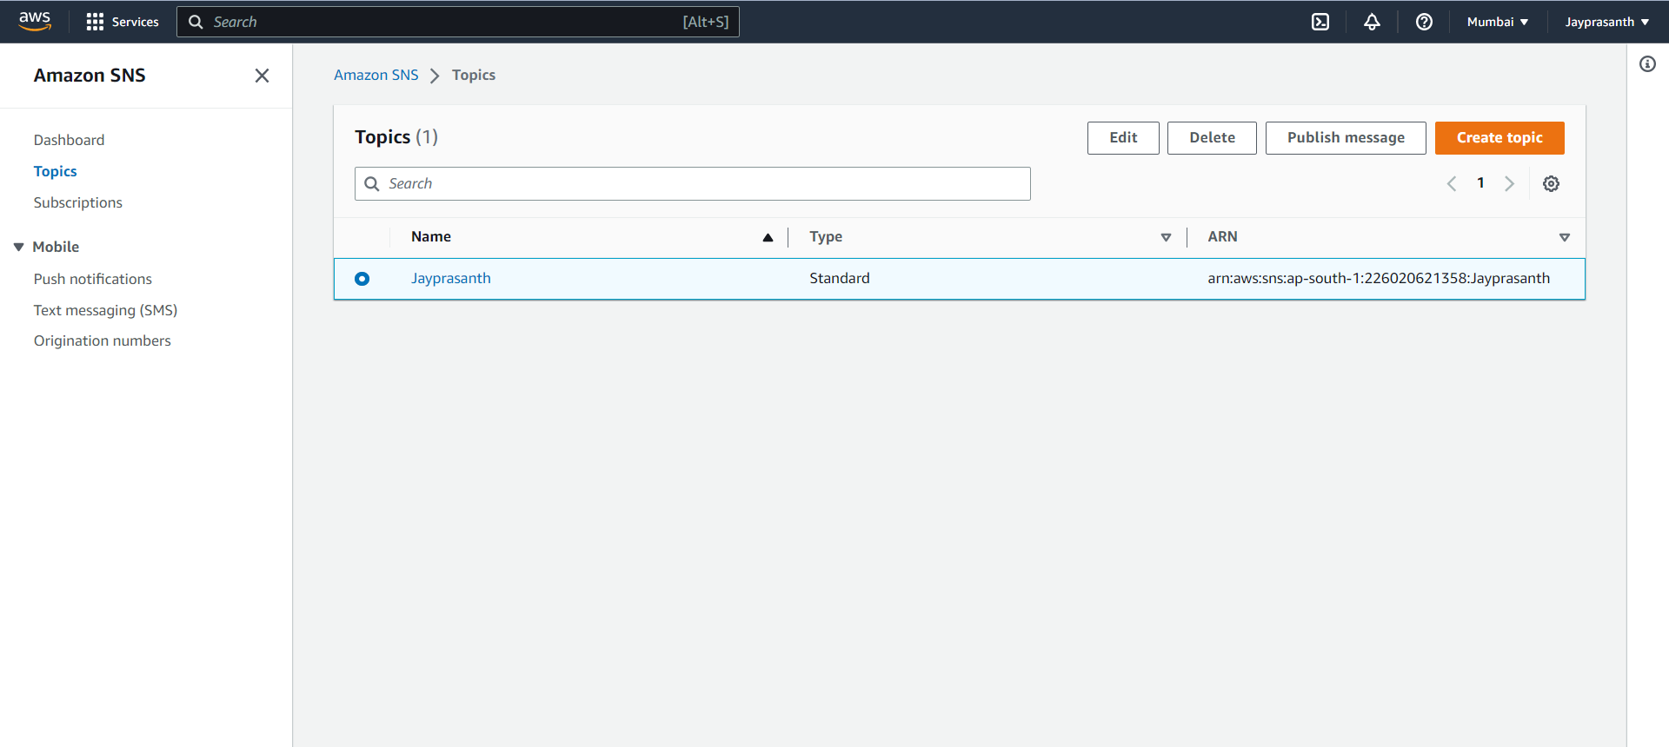

22.Deleted

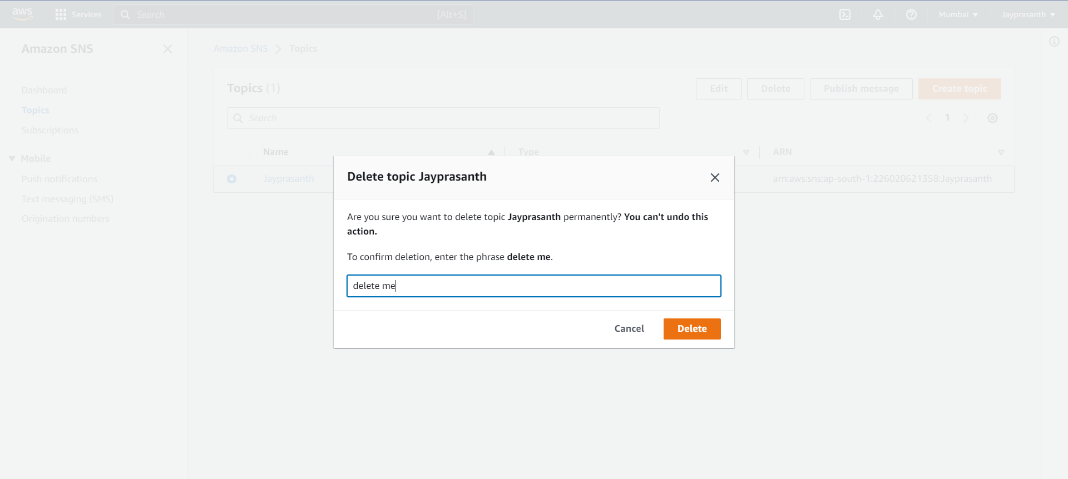

23.Dashboard show the topic or subscription are running

